Fifth Sunday after Pentecost
June 28, 2026

C = Congregation L = Leader ELW = Red Hymnal

GATHERING
The Holy Spirit calls us together as the people of God

PRELUDE

WELCOME AND ANNOUNCEMENTS

CONFESSION AND FORGIVENESS

All may make the sign of the cross, the sign that is marked at baptism, as the presiding minister begins.

L: Blessed be the holy Trinity,☩ one God,
whose compassion endures forever.
C: Amen.
L: Let us confess our sin to God.

Silence is kept for reflection.

L: Compassionate God,
C: we confess to you all our sins.
Our burden is heavy, and we cannot free ourselves.
In your mercy, call us back to you.
Your yoke is easy and your burden is light.
Restore us to dwell in your peace.
In Christ’s name we pray,
Amen.

Jesus says, “Come to me,
all you who are weary
and are carrying heavy burdens,
and I will give you rest.”
In the name of God,
Father, ☩ Son, and Holy Spirit,
your sins are forgiven.
Rest in God’s love.
Amen.

GATHERING SONG God We Gather As Your People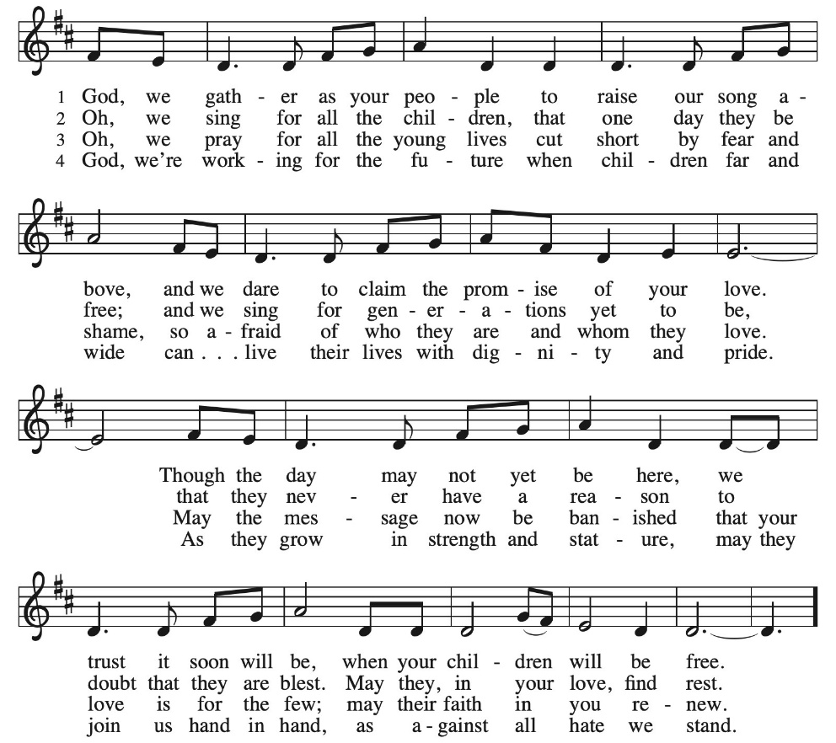
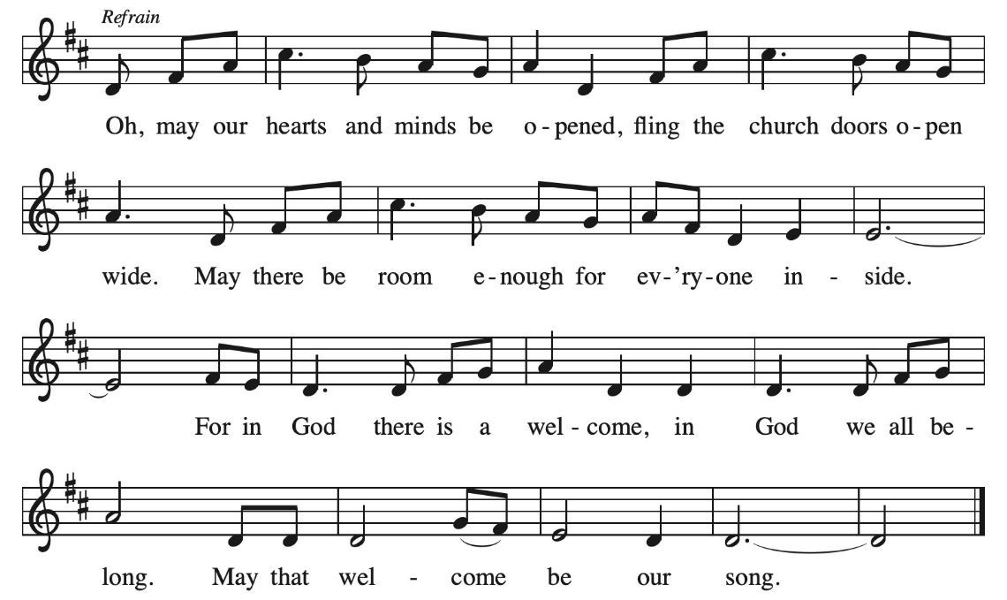

GREETING
L: The grace of our Lord Jesus Christ, the love of God, and the communion of the Holy Spirit be with you all.
C: And also with you.

PRAYER OF THE DAY
L: O God, you direct our lives by your grace, and your words of justice and mercy reshape the world. Mold us into a people who welcome your word and serve one another, through Jesus Christ, our Savior and Lord.
C: Amen

WORD
God speaks to us in scripture reading, preaching and song

FIRST READING Jeremiah 28:5-9

⁵ The prophet Jeremiah spoke to the prophet Hananiah in the presence of the priests and all the people who were standing in the house of the Lord, ⁶ and the prophet Jeremiah said, “Amen! May the Lord do so; may the Lord fulfill the words that you have prophesied and bring back to this place from Babylon the vessels of the house of the Lord and all the exiles. ⁷ But listen now to this word that I speak in your hearing and in the hearing of all the people. ⁸ The prophets who preceded you and me from ancient times prophesied war, famine, and pestilence against many countries and great kingdoms. ⁹ As for the prophet who prophesies peace, when the word of that prophet comes true, then it will be known that the Lord has truly sent the prophet.”

L: Word of God, Word of Life:
C: Thanks, be to God.

GOSPEL ACCLAMATION ELW p. 188 Setting 8
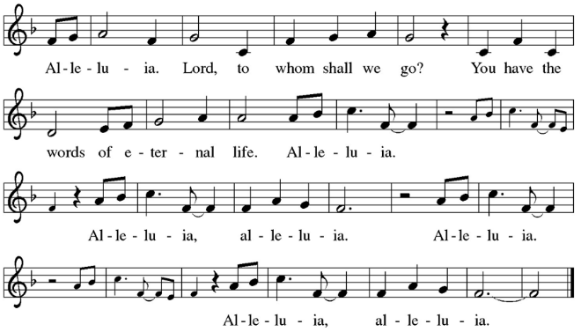
GOSPEL Matthew 10:40-42

L: The Holy Gospel, according to Matthew, the 10th chapter.
C: Glory to you, O Lord.

Jesus said to the twelve: ⁴⁰ “Whoever welcomes you welcomes me, and whoever welcomes me welcomes the one who sent me. ⁴¹ Whoever welcomes a prophet in the name of a prophet will receive a prophet’s reward, and whoever welcomes a righteous person in the name of a righteous person will receive the reward of the righteous, ⁴² and whoever gives even a cup of cold water to one of these little ones in the name of a disciple—truly I tell you, none of these will lose their reward.”

L: The Gospel of the Lord.
C: Praise to You, O Christ.
SERMON Bishop Patricia Lull

SONG OF THE DAY Take My Life/Toma Mi Voluntad, ELW 583

INSTALLATION OF A PASTOR
Presentation
L: Having been authorized by the church to install Bethany Ketchem, our
co-worker in the gospel, as pastor, I now ask for certification of this call.

Congregational Leader: After prayerful deliberation, we, of Our Redeemer Lutheran Church, have called Bethany Ketchem to serve as a minister of word and sacrament
in the position of pastor.
I present Bethany and this letter certifying the call.
Address and Questions
L: A reading from John: Jesus said, “Peace be with you. As the Father has sent me, so I send you. Receive the Holy Spirit. If you forgive the sins of any, they are forgiven them; if you retain the sins of any, they are retained.” (John 20:21-23)
A reading from Matthew: Jesus said, “All authority in heaven and on earth has been given to me. Go therefore and make disciples of all nations, baptizing them in the name of the Father and of the Son and of the Holy Spirit, and teaching them to obey everything that I have commanded you. And remember, I am with you always, to the end of the age.” (Matthew 28:18-20)
A reading from First Timothy: Set the believers an example in speech and conduct, in love, in faith, in purity. Attend to the public reading of scripture, to exhorting, to teaching. Do not neglect the gift that is in you, which was given to you through prophecy with the laying on of hands by the council of elders. Put these things into practice, devote yourself to them, so that all may see your progress. Pay close attention to yourself and to your teaching; continue in these things, for in doing this you will save both yourself and your hearers. (1 Timothy 4:12-16)
L: Bethany, in the presence of this assembly
will you commit yourself to this new trust and responsibility,
in the confidence that it comes from God through the call of the church?
Pastor Bethany: I will, and I ask God to help me.
L: Will you preach and teach in accordance with the holy scriptures
and with the confessions of the Lutheran church?
Will you carry out this ministry in harmony with the constitutions
of the Evangelical Lutheran Church in America?
Pastor Bethany: I will, and I ask God to help me.
L: Will you be diligent in your study of the holy scriptures
and faithful in your use of the means of grace?
Pastor Bethany: I will, and I ask God to help me.
L: Trusting in God’s care,
will you love, serve, and pray for God’s people,
nourish them with the word and sacraments,
and lead them by your own example in faithful service and holy living?
Pastor Bethany: I will, and I ask God to help me.
L: Will you give faithful witness in the world,
that God’s love may be known in all that you do?
Pastor Bethany: I will, and I ask God to help me.
L: Almighty God, who has given you the will to do these things,
graciously give you the strength and compassion to perform them.
C: Amen.
The assembly stands.
L: People of God,
will you receive Bethany as a messenger of Jesus Christ
sent to serve all people with the gospel of hope and salvation?
Will you regard Bethany as a servant of Christ and a steward of the mysteries of God?
C: We will, and we ask God to help us.
L: Will you pray for Bethany?
Will you help and honor Bethany in carrying out this ministry?
In all things, will you strive to live together in the peace and unity of Christ?
C: We will, and we ask God to help us.
L: Bethany the office of Pastor is now committed to you
in the name of the Father, and of the Son, and of the Holy Spirit.
C: Amen.
Blessing
L: The God of peace, who brought again from the dead our Lord Jesus,
the great shepherd of the sheep, by the blood of the eternal covenant,
make you complete in everything good so that you may do God’s will,
working in you that which is pleasing in God’s sight;
through Jesus Christ, to whom be the glory forever and ever.
C: Amen.
L: You have been called to be among us to baptize, to teach, and to forgive sins.
L: You have been called to be among us to proclaim the good news.
L:
You have been called to be among us to preside at the Lord’s supper.
People of God, I present to you Bethany, your pastor.
Let us welcome her in the name of Christ.
The assembly may offer acclamation with applause.

PRAYERS OF THE PEOPLE
L: God of grace,
C: Hear our prayer.

PEACE
L: The peace of the Lord be with you all.
C: And also with you.

MEAL
God feeds us with the presence of Jesus Christ

OFFERING Softly and Tenderly, W. Thompson Arr. J. Raney
Jeremy Mattson, Piano

OFFERING RESPONSE What Have We To Offer?
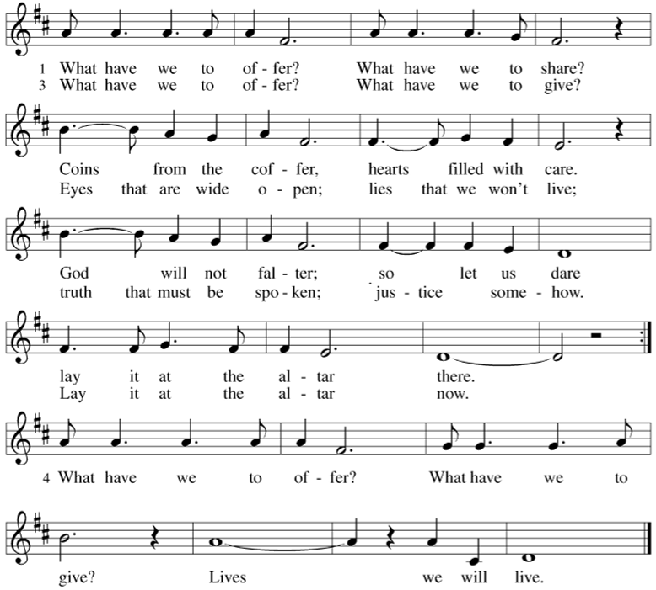

OFFERING PRAYER
L: Loving God, we offer at your table the gifts of our hearts. Help us take heart in you and share freely of your love, so that all creation can taste your abundance. We ask this in the name of Jesus, through the Spirit abiding with us now and forever.
C: Amen.

GREAT THANKSGIVING

DIALOGUE AND PREFACE
L: The Lord be with you.
C: And also with you.

L: Lift up your hearts.
C: We lift them to the Lord.

L: Let us give thanks to the Lord our God.
C: It is right to give our thanks and praise.

L: It is indeed right...and join your unending hymn.

HOLY, HOLY HOLY ELW p.190, Setting 8

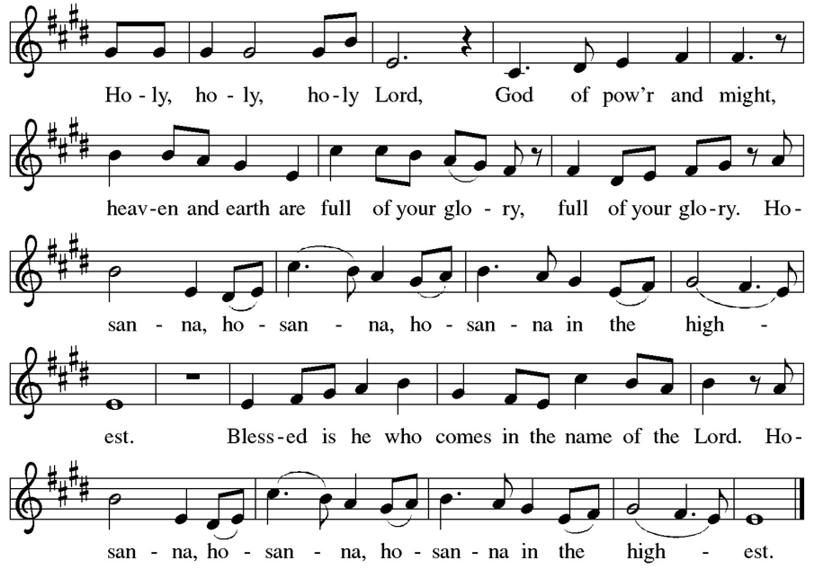
WORDS OF INSTITUTION

LORD’S PRAYER
C: Our Father in heaven, hallowed be your name, your kingdom come, your will be done, on earth as in heaven. Give us today our daily bread. Forgive us our sins as we forgive those who sin against us. Save us from the time of trial and deliver us from evil. For the kingdom, the power, and the glory are yours, now and forever. Amen.

COMMUNION

LAMB OF GOD ELW p. 191, Setting 8
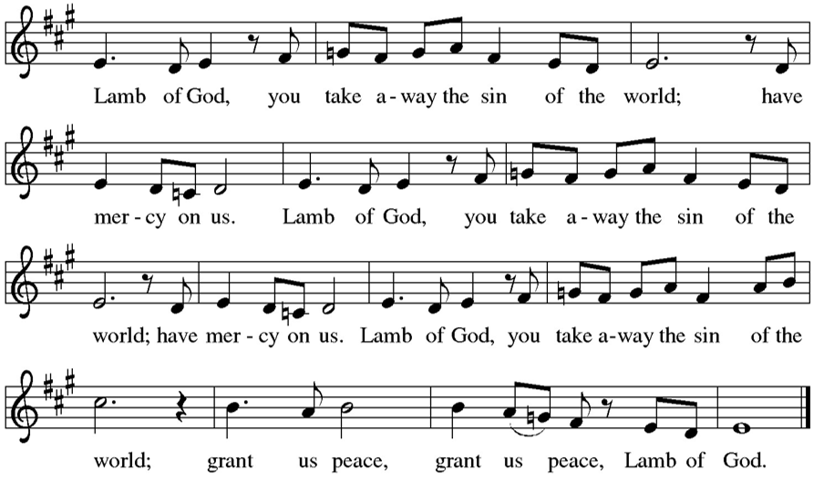

COMMUNION SONG Let Streams of Living Justice, ELW 710
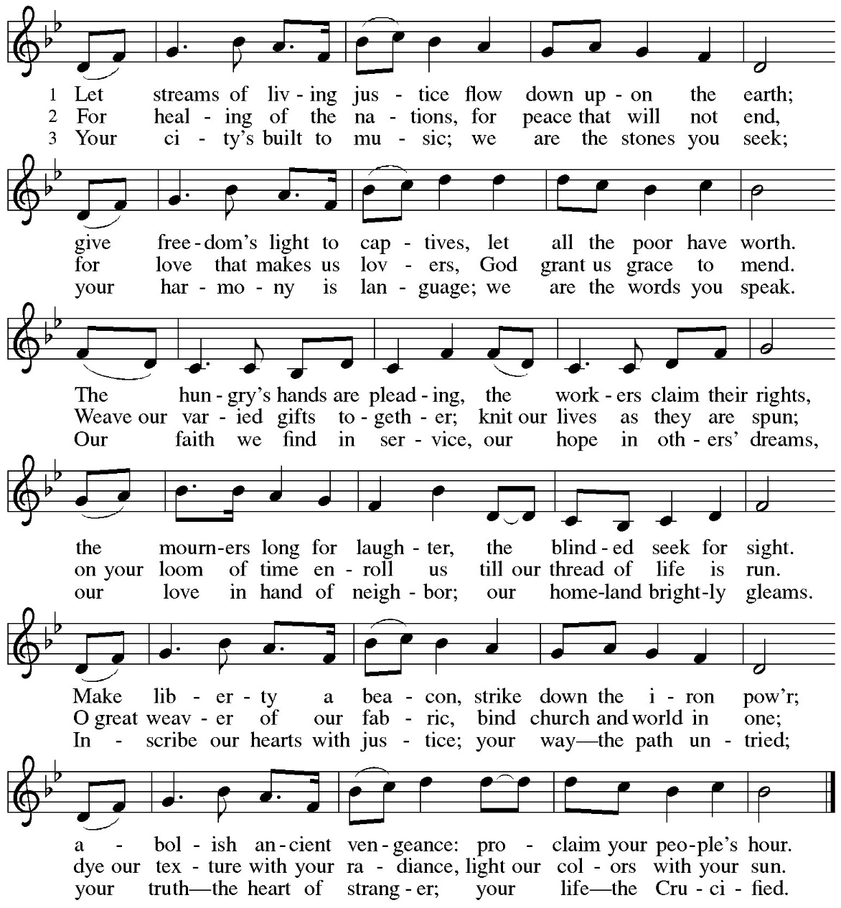

PRAYER AFTER COMMUNION
L: Compassionate God, through the gifts of bread and wine our hearts are filled with the abundance of your love. Strengthen us that we, through this holy meal, may share your love freely, as you have shared with us. We ask this in the name of Jesus, through the Spirit nourishing us now and forever.
C: Amen.

SENDING
God blesses us and sends us in mission to the world

BLESSING

L: Creator, Redeemer, Sustainer, ☩ one God, bless, heal, and hold you
today and always.
C. Amen

SENDING SONG Build a Longer Table

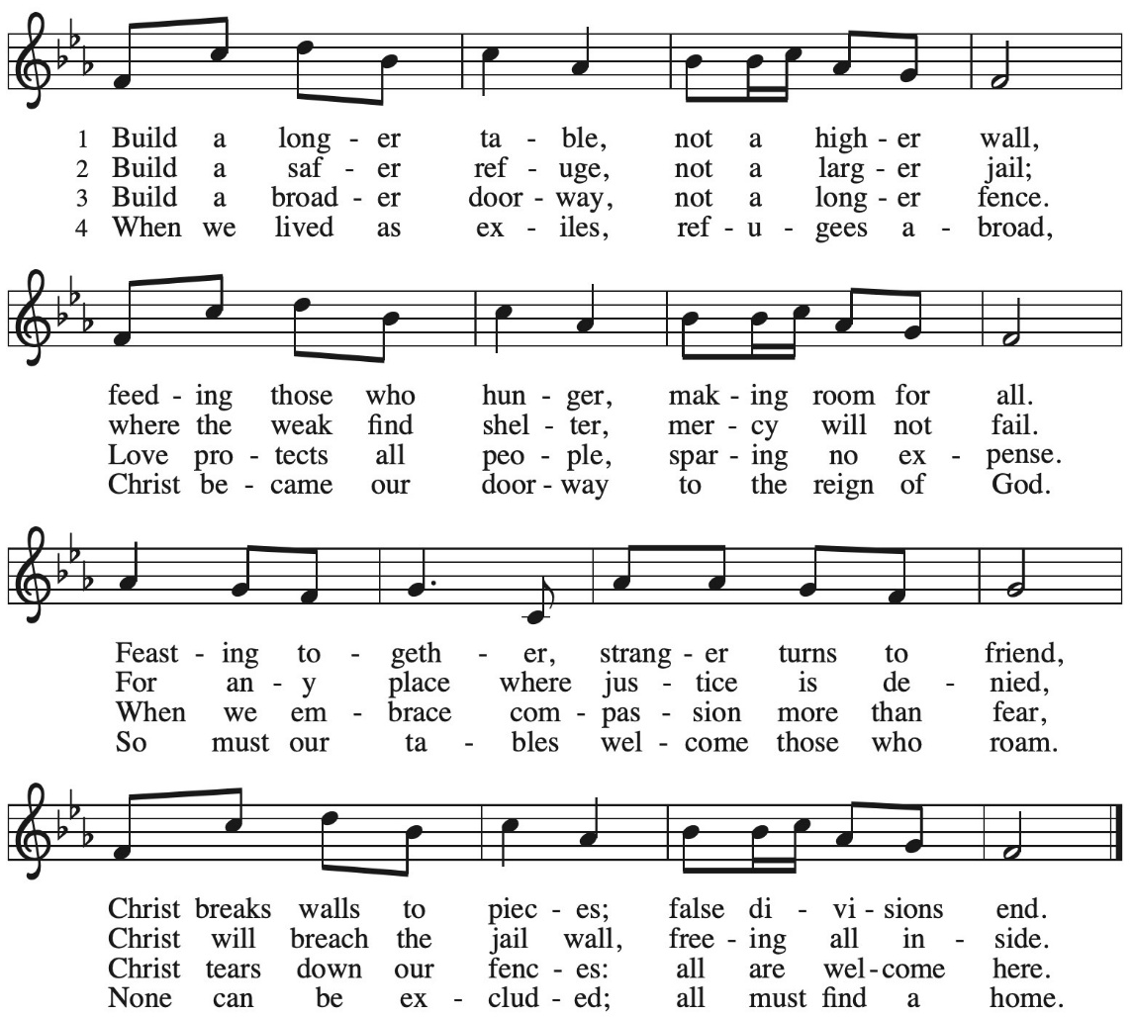

DISMISSAL

L: Heaven has come near. Go, share the good news!
C: Thanks be to God.

POSTLUDE
Acknowledgements: Used by permission of Augsburg Fortress under license #SB165014. Printed and projected by permission of CCLI License #518924. Streamed by permission of CCLI License #20572533.

ANNOUNCEMENTS

The Semi-annual Congregational Meeting will be today after service.

Prayers & Praises of the People:
- Prayers for Sharon Peterson as she continues to recover.
- Prayers for Kathi Kirchoff: prayers for her chemotherapy treatments.
- Prayers for healing for Judy Koza.

Lessons for next Sunday, July 5:
Zechariah 9:9-12 and Matthew 11:16-19, 25-30
Next week’s lector: Cherie Kilbride

Participants in Today’s Service
Bishop Rev. Patricia Lull
Pastor Rev. Bethany Ketchem
Worship & Music Director Jeremy Mattson
Director of Choir and Handbells Alex Carlson
Soundboard & Livestream Beth Renfors
Lector Jessica Prenzlow-Morgan

Our Redeemer Lutheran Church
1390 Larpenteur Avenue East, Saint Paul, MN 55109
Phone: 651-772-2445 | Email: office@orlcmn.org
Prayer Requests: prayers@orlcmn.org
Giving: Offerings@orlcmn.org or text 844-871-2328

